- Number of using Cab Devices(Scenario list)
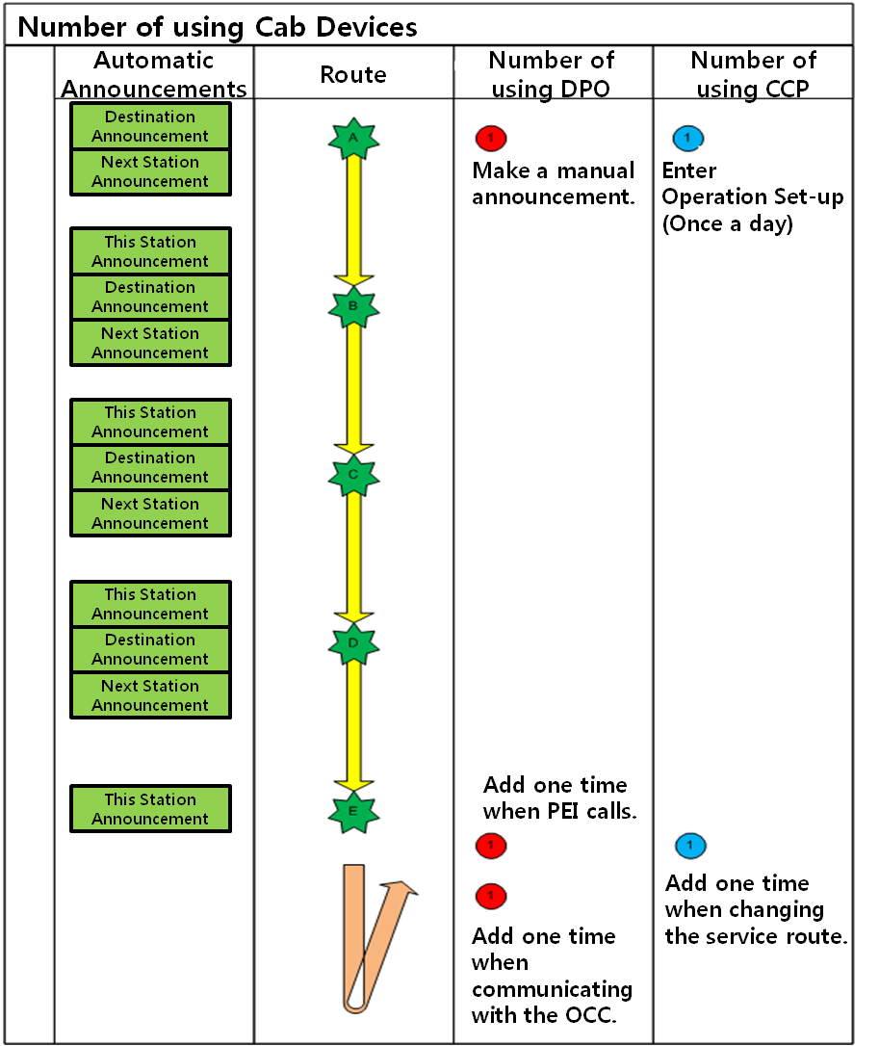
- PEI – DPO Communication Function Identification.
# OCC/PEI/Cab to Cab Communication Procedure in an Operator position
2.1 Leading Cab Communication Procedure.
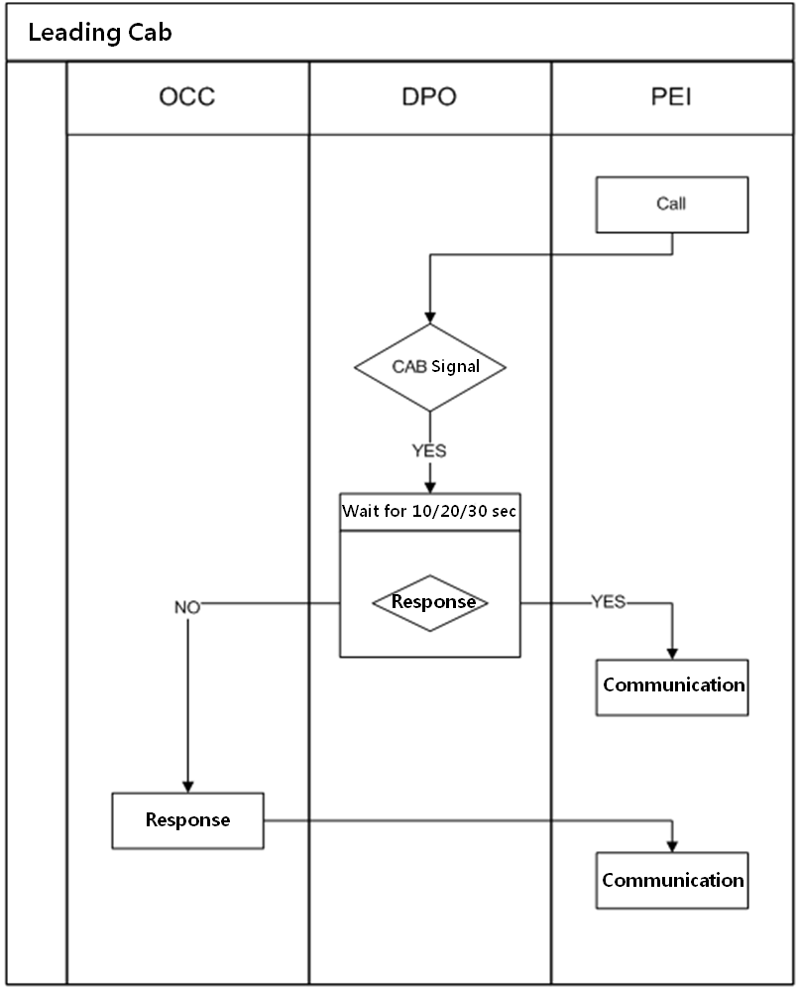

  - Non-Leading Cab Procedure.
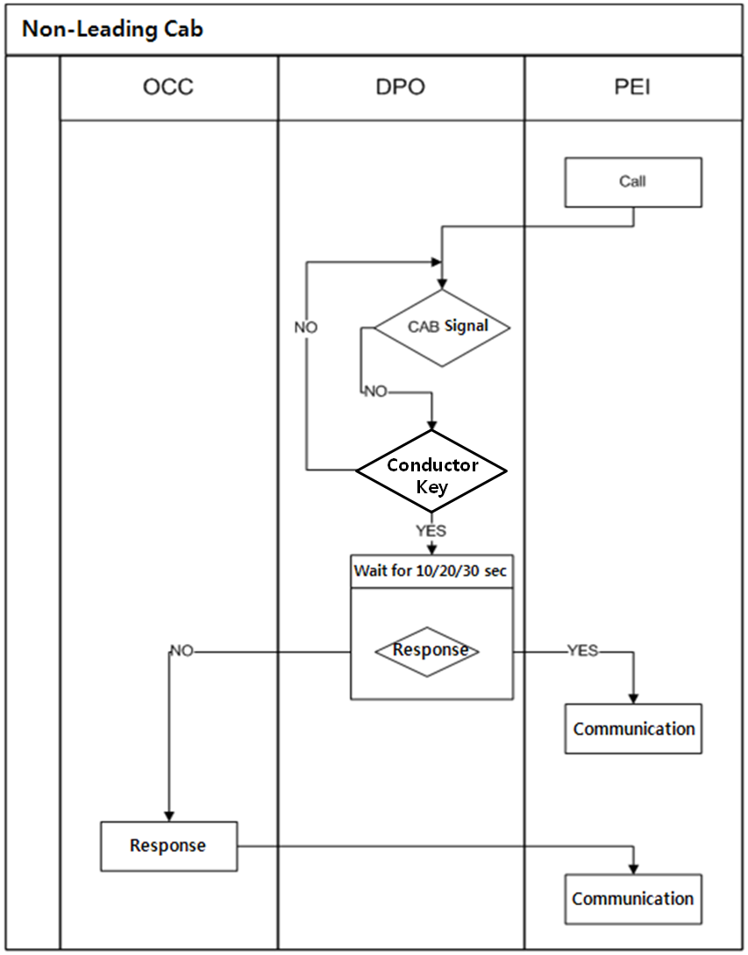

- Device with Alarm Sound
3.1 Device Classification.
 | Device installed in CAB | Device installed in Passenger Compartment
PEI | - | Announcement which will be played when the PEI push button has been pressed.  - Woojin is reviewing the CAB only announcement or alarm sound as DENVER request to eliminate the emergency announcement in the vehicle.

- Software Update Procedure
